Polygonal numbers

The triangle numbers:
are given by the recurrence relation:
and
So:
andandetc
So:

In general:

NEED BETTER DIAGRAM

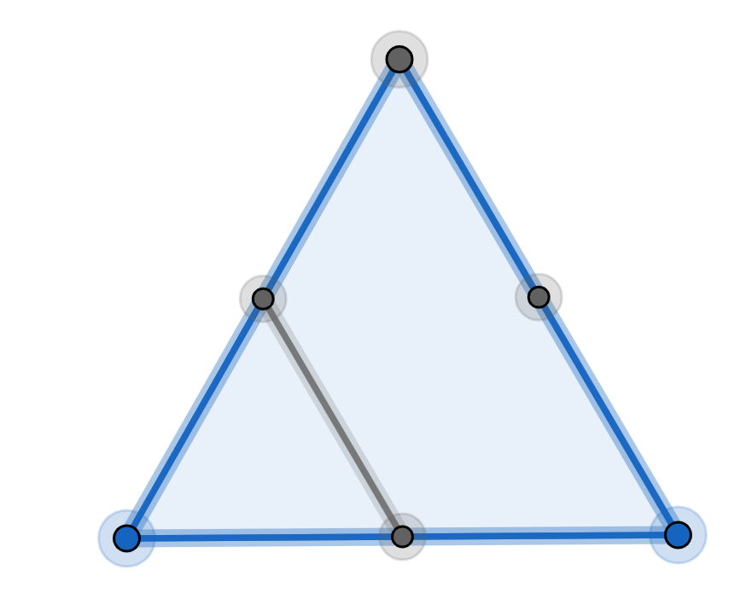

Theorem:

Proof (by induction)
part 1:
Ifthen:
andSo the formula is true when
part 2:
Ifis true whenthen:
but
So:

So:
is true when

The square numbers:
are given by the recurrence relation:
and
So:
andandetc
Show that:

NEED BETTER DIAGRAM
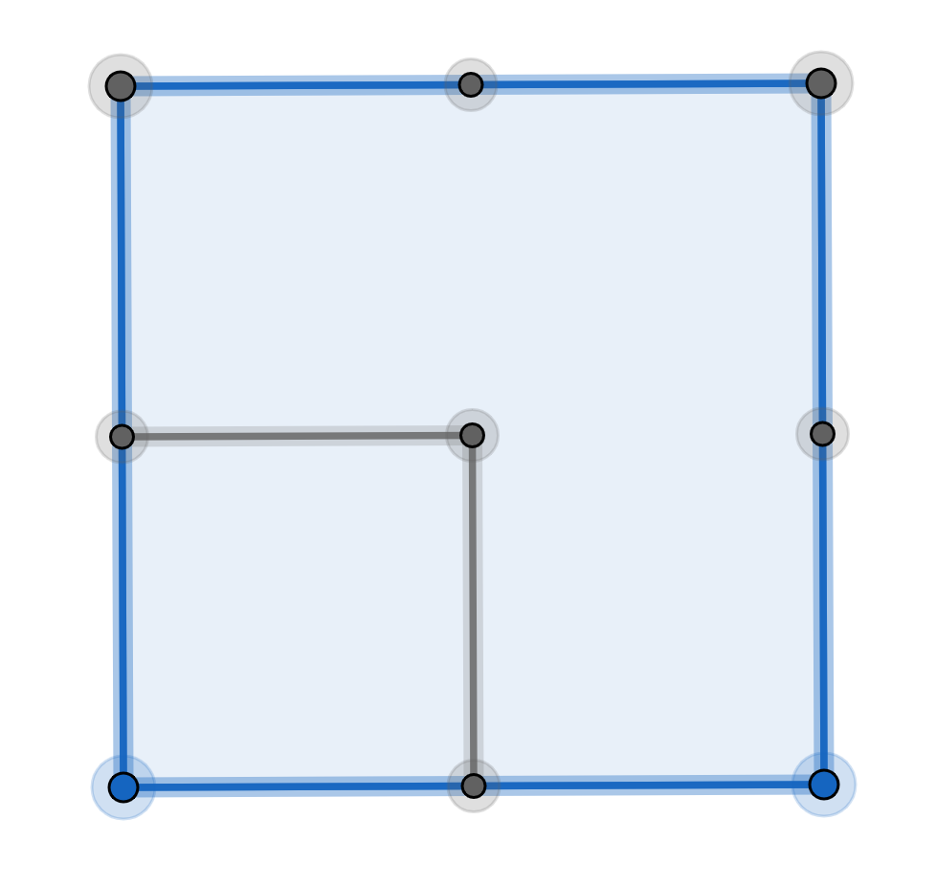

Theorem:
or if you prefer

see Exercise 1

The pentagonal numbers:
are given by the recurrence relation:
and
So:
andandetc
Show that:

NEED BETTER DIAGRAM
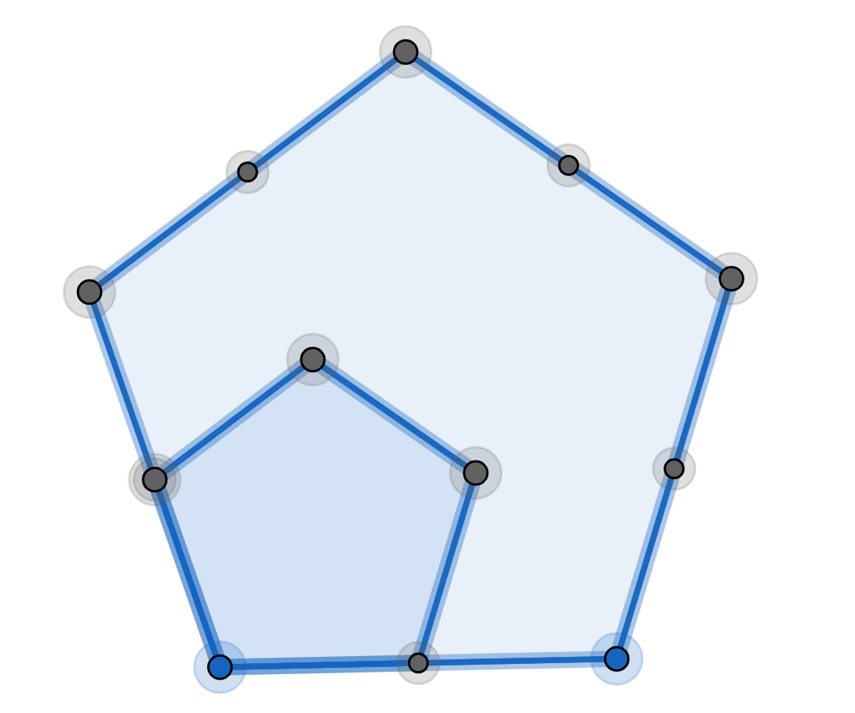

Theorem:

The hexagonal numbers:
are given by the recurrence relation:
and
So:
andandetc
Show that:

NEED BETTER DIAGRAM

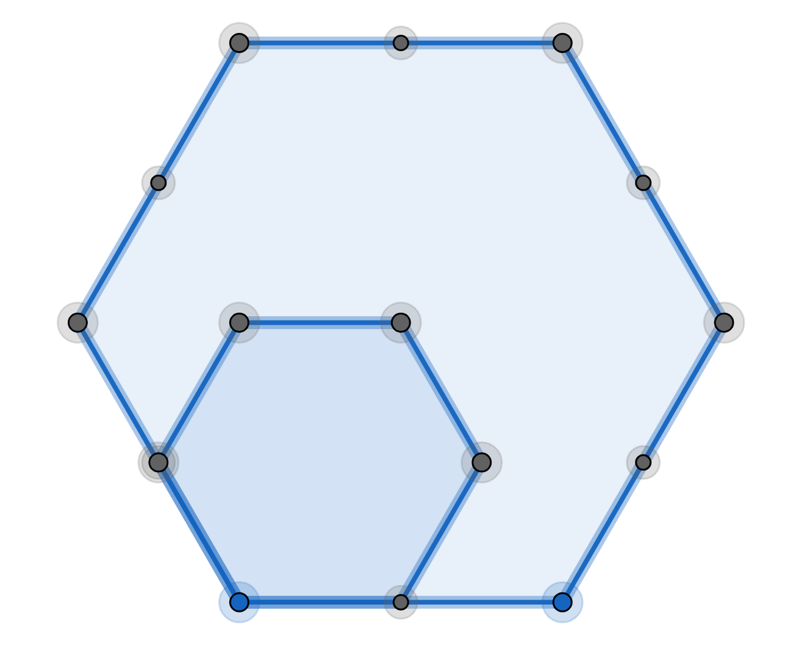

Theorem:

The polygonal number theorem (difficult to prove)
Every positive integer can be written as the sum of:
3 (or fewer) triangle numbers
4 (or fewer) square numbers
5 (or fewer) pentagonal numbers
etc

see Exercise 2

EXERCISE 1
Square numbers:
Show thatUse proof by induction

EXERCISE 2
Prove the following:
1. The sum of two consecutive triangle numbers is a square number.
2. Ifis a triangle number thenis a square number.
3. Ifis a triangle number thenis a triangle number.
4. The difference of the squares of two consecutive triangle numbers is a cube.
5.
6.
7. The last digit of a triangle number can’t be 2, 4, 7 or 9

SOLUTIONS 1
Proof (by induction)
part 1:
If thenandSo the formula is true when
part 2:
Ifis true whenthen:
but
So
Sois true when

SOLUTIONS 2
1)

Or:
In this diagram we have got:Ps andQs
How many letters have we got?

Q | Q | Q | Q | Q | Q
P | Q | Q | Q | Q | Q
P | P | Q | Q | Q | Q
P | P | P | Q | Q | Q
P | P | P | P | Q | Q
P | P | P | P | P | Q

In general

2)
3)
4)
5)

6)

7) mod 10:
 | 0 | 1 | 2 | 3 | 4 | 5 | 6 | 7 | 8 | 9
 | 1 | 2 | 3 | 4 | 5 | 6 | 7 | 8 | 9 | 0
 | 0 | 2 | 6 | 2 | 0 | 0 | 2 | 6 | 2 | 0

nowsoso the last digit ofis 0, 2 or 6

mod 10:
 | 0 | 1 |  | 3 |  | 5 | 6 |  | 8
 | 0 | 2 |  | 6 |  | 0 | 2 |  | 6

If the last digit ofis 0, 2 or 6 then the last digit ofmust be 0, 1, 3, 5, 6 or 8

